**3D PRINTER MATERIALS PRECDICTION**

**USING IBM WATSON**

An Internship Project Report

Submitted By

(BATCH NO: IT_AIML_B03)

P.RAJESWARI (18481A1281)

                              SK.AZEEZ (18481A1288)

JAYA SURYA SIMHA (18481A1297)

A.MOHAN SAI (19485A1210)

**INDEX**

**TITLE PAGE NO**

**CHAPTER 1: INTRODUCTION 3-4**

* 1. OVERVIEW 3-4
  2. PURPOSE 4

**CHAPTER 2: LITERATURE SURVEY 5**

* 1. EXISTING PROBLEM 5
  2. PROPOSED SOLUTION 5

**CHAPTER 3: THEORTICAL ANALYSIS 6-8**

3.1 BLOCK DIAGRAM 6

3.2 HARDWARE/SOFTWARE DESIGNING 7-8

**CHAPTER 4: EXPERIMENTAL INVESTIGATIONS 9-10**

**CHAPTER 5: FLOW CHART 11-12**

**CHAPTER 6: RESULTS 12**

**CHAPTER 7: ADVANTAGES AND DISADVANTAGES 13**

**CHAPTER 8: APLLICATIONS 13**

**CHAPTER 9: CONCLUSION 13**

**CHAPTER 10: FUTURE SCOPE 14**

**CHAPTER 11: BIBILOGRAPHY 15**

**CHAPTER 1**

**INTRODUCTION**

* 1. **Overview:**

The goal of this analysis is to create a model that suggests the best material to use for the required 3D shape among ABS (Acrylonitrile Butadiene Styrene) and PLA (Poly-actic Acid). Let’s understand the data we’re working with and give a brief overview of what each feature represents or should represent.

1. Layer Height (mm) – Height of the layer

2. Wall Thickness (mm) – Thickness of wall of desired 3d shape

3. Infill Density (mm) – Density of infill

4. Infill pattern – Grid or Honeycomb

5. Nozzle Temperature (°C) – Temperature of nozzle

6. Bed Temperature (°C) - Temperature of printing bed

7. Print speed (mm/s) – Speed of printing

8. Fan speed (mm/s) – speed of fan

9. Roughness

10. Tension strength

11. Elongation

**1.2 Purpose:**

By 3D Printer Materials Prediction Using IBM Watson we will:

* Know fundamental concepts and can work on IBM Watson Studio.
* Gain a broad understanding of Binary Classification.

**CHAPTER 2**

**LITERATURE SURVEY**

* 1. **Existing Problem:**

Determining the best material for 3D printer is a difficult task for a human as he has to consider different number of parameters and come up with a conclusion. Once after deciding the material we can’t roll back the task of printing and sometimes it turns out to a huge loss.

It is quite difficult for a human to work with such a huge and typical data. So here we are coming up with a solution.

* 1. **Proposed Solution:**

Artificial Intelligence being the trending technology can end up with the best solution for every typical problem. So here we are going to use the rich set of Machine Learning algorithms to predict the material.

By using the supervised learning algorithms of Machine learning such as decision tree we decide the material to be used.

**CHAPTER 3**

**THEORTICAL ANALYSIS**

**3.1 Block Diagram:**

JUPYTER NOTEBOOK ON IBM

LOADING THE DATASET INTO IBM WATSON STUDIO

IBM WATSON STUDIO

READING THE DATASET AND DECIDING THE ALGORITHM AND TRAINING THE MODEL

TESTING THE MODEL

IBM CLOUD ACCOUNT

**3.2 Hardware/software designing:**

**Software specifications:**

|  |  |
| --- | --- |
| **REQUIREMENT** | **SPECIFICATION** |
| Anaconda Navigator | You must have anaconda installed in your device prior to begin. |
| Spyder, Jupyter Notebook, Flask  Frame work | 1. One should have Spyder and Jupyter notebook. 2. One should install flask framework through anaconda prompt for running their web application 3. We need to build the model using jupyter notebook with all the imported packages. |
| Web browser | For all Web browsers, the following must be enabled:   * cookies * JavaScript |

**Hardware Specifications:**

|  |  |
| --- | --- |
| **REQUIREMENT** | **SPECIFICATIONS** |
| Operating system | Microsoft Windows  UNIX  Linux® |
| Processing | Minimum: 4 CPU cores for one user. For each deployment, a sizing exercise is highly recommended. |
| RAM | Minimum 8 GB. |
| Operating system specifications | File descriptor limit set to 8192 on UNIX and Linux |
| Disk space | A minimum of 7 GB of free space is required to install the software. |

**CHAPTER 4**

**EXPERIMENTAL INVESTIGATIONS**

Analysis or the investigation made while working on the solution:

While working on the solution we investigated on what is 3D Printing, IBM cloud, IBM Watson studio, Machine Learning service, Cloud Object Storage. The key role on investigation is collection of dataset.

**IBM Cloud Account**:

IBM Acquired soft layer, a public cloud platform, to serve as the foundation for its IaaS offering. In October 2016, IBM rolled the soft layer brand under its Blue mix brand of PaaS offerings, giving users to access both IaaS and PaaS resources from a single console. IBM cloud provides a full-stack, public cloud platform with various products in the catalog, including options for compute, storage, networking, end to end developer solutions for app development, testing and deployment, security databases, and cloud native services.

Creating the IBM cloud account by going to the IBM cloud login page and click create on IBM cloud account. Enter our IBM id and an ID is created based on the email that we enter. Completing the remaining fields with our information and click create account by this the account is created.

**Dataset collection**:

The data collection on 3d printer by:

* Articulate the problem early.
* Establish data collection.
* Check our data quickly.
* Format data to make it consistent.
* Reduce data.
* Complete data cleaning.
* Decompose data.
* Take the required fields of data

**CHAPTER 5**

**FLOW CHART**



Data Collection



Data

Visualization



Identify dependent and independent attributes



Identify the required columns



Apply decision tree algorithm



Split data into train and test



Save the model



Test the model



Create a flask application and link it

t

Deploying in IBM cloud

**CHAPTER 6**

**RESULTS**

**Final output of the project:**

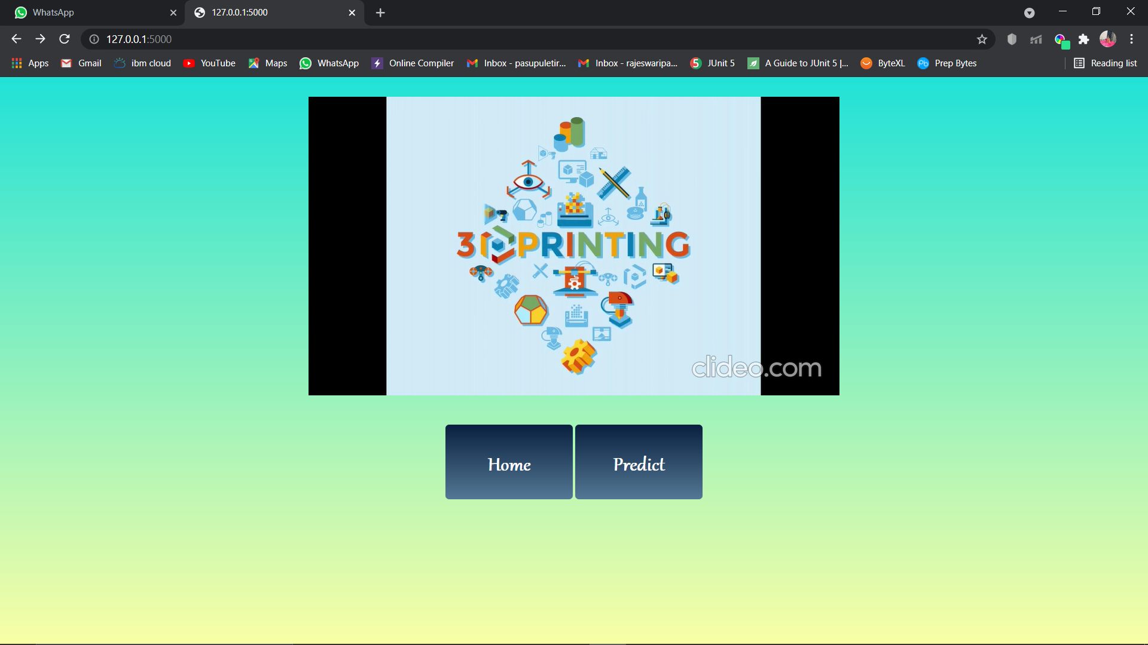

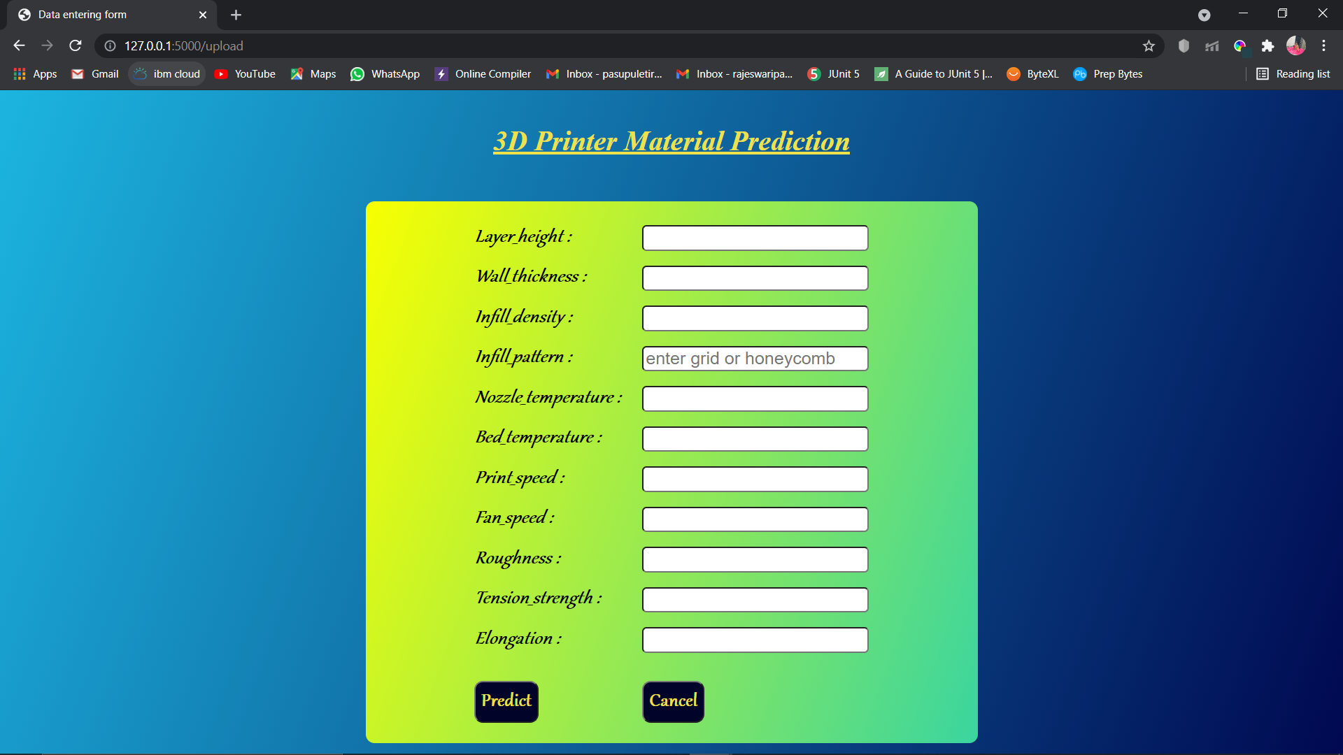

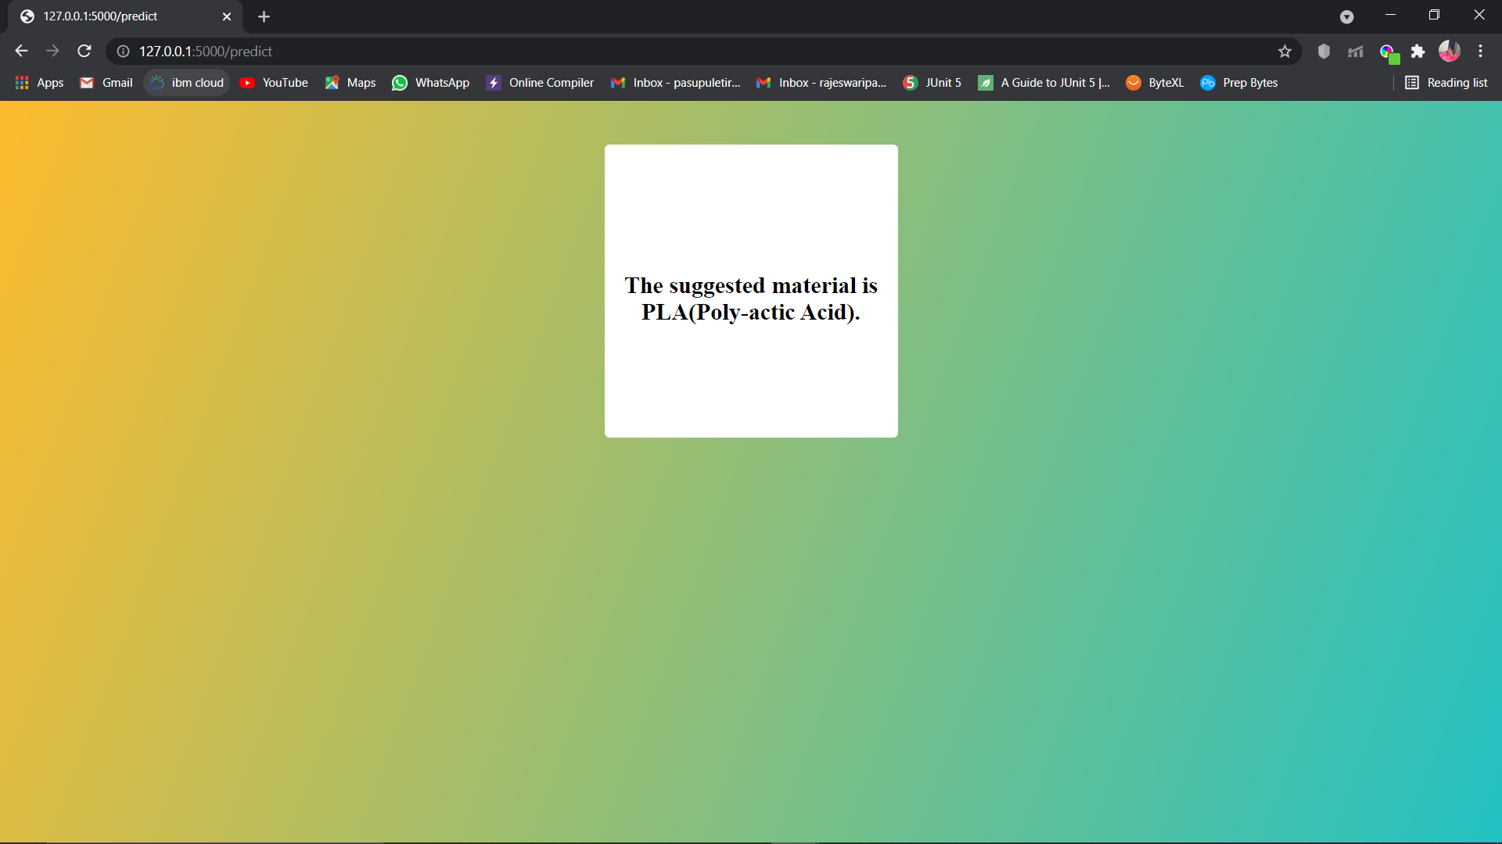

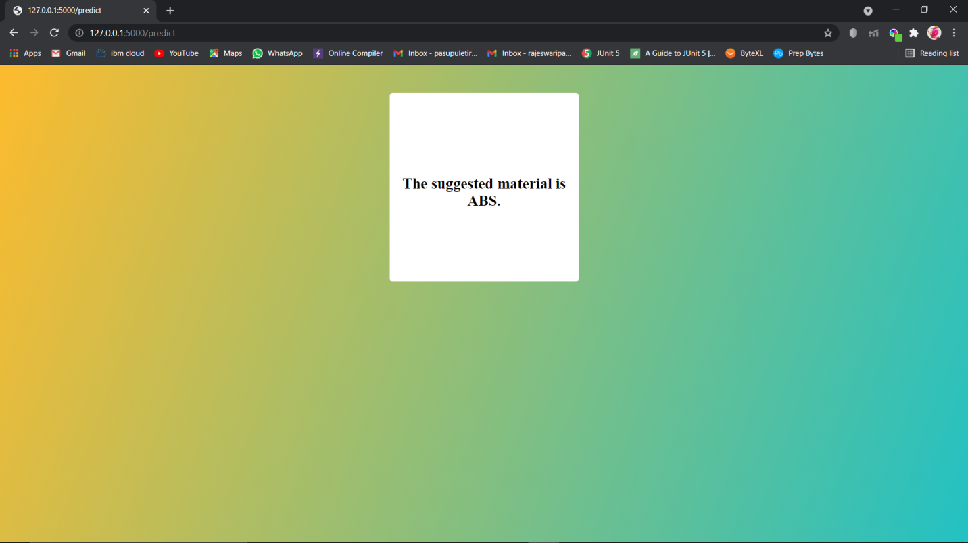

**CHAPTER 7**

**ADVANTAGES AND DISADVANTAGES**

**Advantages:**

* Lower costs - reduces maintenance due to complete report coverage and a zero-footprint environment.
* Faster results - shortens reporting time due to seamless integration and adaptive authoring.
* High performance data access across all source.

**Disadvantages:**

* The permission level for a user cannot be modified
* Data grouping
* Custom visualizations
* Insights in visualization

Lower c Lower costs—reduces maintenance due to complete report co

-footprint environment.

Faster results—shortens reporting time due to seamless integration and adaptive authoring.

Improved decision making—reports and dashboards present data in easily-understood formats.

High performance data ac **CHAPTER 8**

**APLLICATIONS**

**The areas where this solution can be applied:**

* 3D Printing Industry
* Where there is an ambiguity between two materials.

**CHAPTER 9**

**CONCLUSION**

**From this entire findings we know fundamental concepts and can work on IBM Watson and machine learning.**

* Gain a board understanding of Binary classification algorithms.
* Learn to build stunning models on IBM cloud.
* To create data visualizations to understand.

**CHAPTER 10**

**FUTURE SCOPE**

**Enhancements that can be made in the future:**

* This model can be further developed to suggest material among all the possible materials based on the input parameters.
* We can scope the better job in future with easy experience.

**CHAPTER 11**

**BIBILOGRAPHY**

References of previous works or websites visited/books referred for analysis about the project, previous solution findings https://www.analyticsvidhya.com/blog/2017/09/common-machine-learning-algorithms/